8/10/2026
LAB NO 05
Operating System Lab
Instructor: Ms. Muneeba Banaras
Submitted By: Wasif Ali
Reg ID: 245187
Class: BSCS F’24 B

LAB TASK
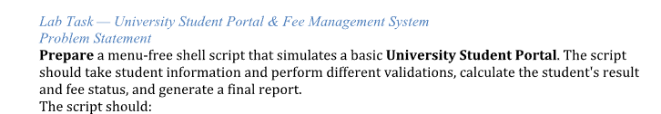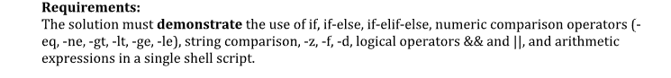

Script File (Shell Script Code):
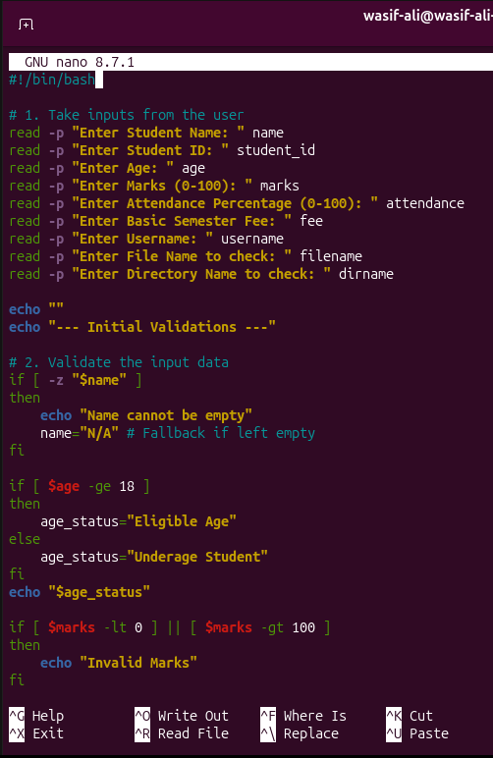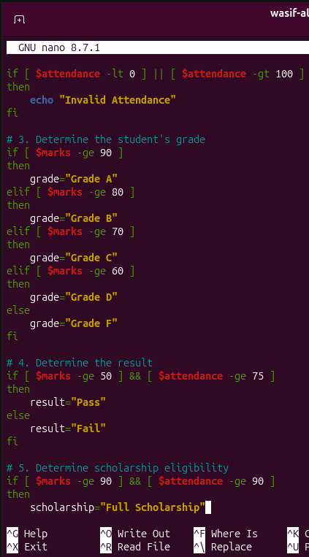
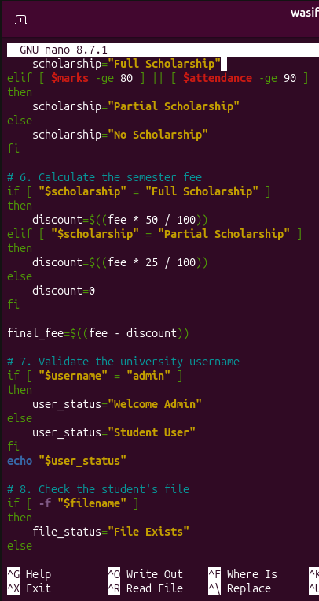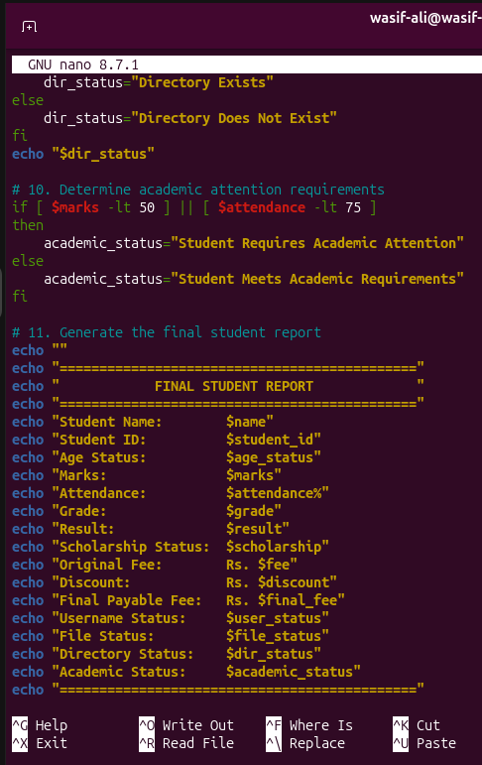

Command
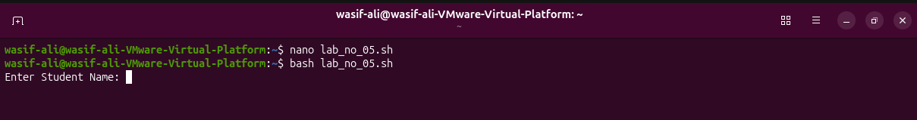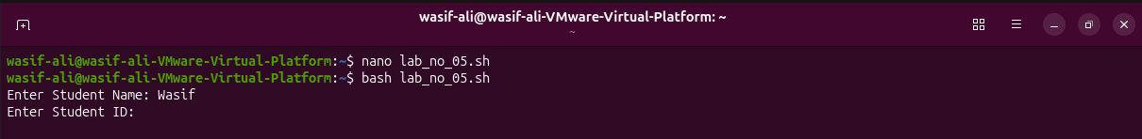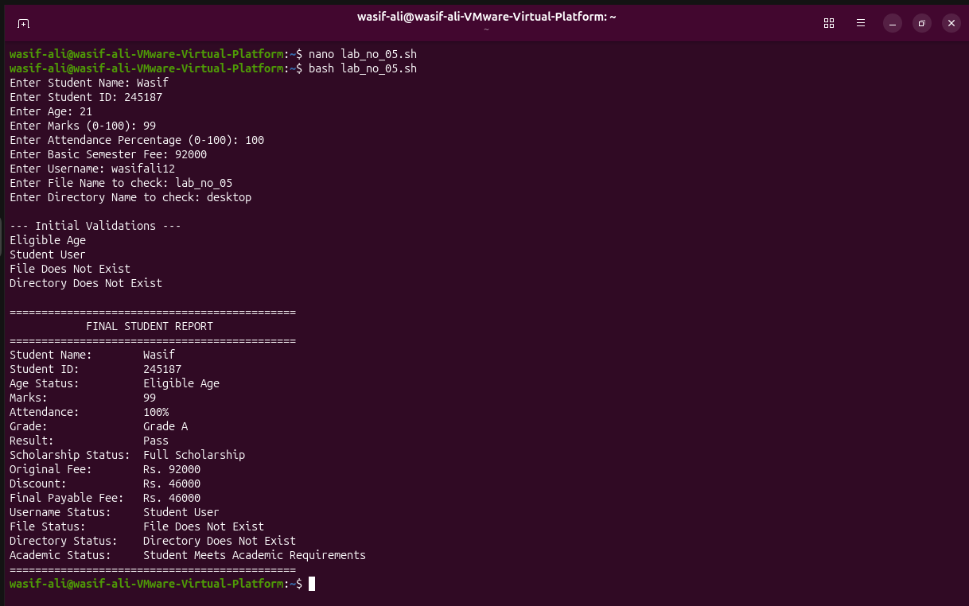
University Student Portal & Fee Management System Description
- Data Collection: Prompts the user to enter nine specific data points, including academic performance, financial details, and system file names.
- Input Validation: Verifies that the student's name is not left empty using the -z flag, categorizes the student's age (18+ as eligible), and identifies if the entered marks or attendance fall outside the valid 0-100 range.
- Academic Grading & Results: Uses an if-elif-else ladder to assign a letter grade (A through F) based on marks, and uses the logical && operator to grant a "Pass" status only if marks are at least 50 and attendance is at least 75%.
- Scholarship & Fee Calculation: Evaluates scholarship tiers using both && (Full Scholarship for 90+ marks and 90%+ attendance) and || (Partial Scholarship for 80+ marks or 90%+ attendance) operators, subsequently calculating a 50% or 25% fee discount using arithmetic expressions.
- System Verification: Compares the entered username to "admin" to determine access level, and utilizes the -f and -d flags to confirm whether the specified file and directory actually exist on the system.
- Final Reporting: Flags the student for academic attention if they fail to meet minimum marks or attendance thresholds, and prints a consolidated, formatted summary report of all evaluated data.

